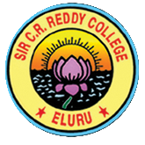

SIR C R REDDY COLLEGE FOR BOYS, ELURU.

CONDUCT & STUDY CERTIFICATE

This is to certify that Mr ………………………………………………………………...............

S/o. ……………………………………………………… studied / is studying ……………………………..

Course during the period ………………………………………………………………………………….....

at Sir C R Reddy College for Boys, Eluru.

His Admission No. is ………………………………….. He is appearing / appeared for final

Examination in March / April. With Regd. No. ……………………………………………………..

His Conduct is ………………………………………………………….

Place:

Date: ***Principal***